The Field Project Report
For Bachelor of Science (Data Science)
“Survey on Digital Learning Tools Usage Among College Students”
Submitted to
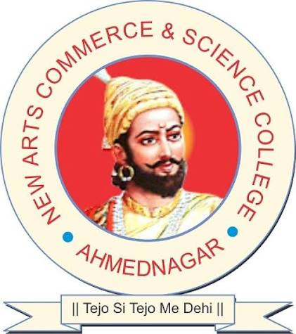
Department of Data Science, CASAS
New Arts, Commerce and Science College, Ahmednagar (Autonomous)
In
“Bachelor of Science (Data Science)”
Submitted by
Waghmare Ganesh Jalindar
Class: SY B.Sc. Data Science | Roll No./PRN: 81
Under the Guidance of
Prof. Arjana Shaikh
September 2026
Ahmednagar Jilha Maratha Vidya Prasarak Samaj's
NEW ARTS, COMMERCE AND SCIENCE COLLEGE, AHMEDNAGAR (Autonomous)
DEPARTMENT OF DATA SCIENCE, CASAS
CERTIFICATE
This is to certify that the work incorporated in the field project report on “Survey on Digital Learning Tools Usage Among College Students” submitted by Waghmare Ganesh Jalindar, student of New Arts, Commerce and Science College, Ahmednagar (Autonomous), is submitted in partial fulfilment of the requirement for the Bachelor of Science (Data Science) degree.

Project Guide Head of the Department
(Prof. Arjana Shaikh) (Prof. Arun D. Gangarde)

Place: Ahmednagar
Date:

Acknowledgement
I express my sincere gratitude to my project guide, Prof. Arjana Shaikh, for the constant guidance, valuable suggestions and encouragement throughout this field project. I am thankful to the Head of the Department and all faculty members of the Department of Data Science, CASAS, for their support, and to the Principal and the College for providing this opportunity under NEP 2020.
I am especially grateful to all the students who spared their valuable time to respond to the survey questionnaire and shared honest information about their use of digital learning tools, without whom this study would not have been possible.
Finally, I thank my parents and friends for their constant support during the course of this field work.
– Waghmare Ganesh
INDEX
Ch. No. | Title | Page No.
1 | Certificate | 2
2 | Acknowledgement | 3
3 | Introduction: Origin of the Problem, Aim and Objectives | 5
4 | Methodology: Type of Study, Sample, Questionnaire, Area Covered | 8
5 | Profile of the Study Area / College | 10
6 | Data Analysis: Tables, Charts and Interpretation | 12
7 | Findings, Conclusions and Recommendations | 34
8 | Learning Outcomes and Personal Experience | 37
9 | References | 39
10 | Annexure A: Blank Questionnaire / Filled Questionnaires | 40
11 | Annexure B: Continuous Assessment Chart (signed) | 44
12 | Annexure C: Letter of Authority (copy) and Field Photographs | 45

3. Introduction: Origin of the Problem, Aim and Objectives

3.1 Introduction and Origin of the Problem
Digital technology has become an important part of modern education. College students increasingly use digital learning tools such as Google Classroom, YouTube, online learning platforms, educational applications, video conferencing tools, e-books, digital notes, and Artificial Intelligence-based tools to support their studies.
These tools provide students with easy access to learning resources, flexible learning opportunities, quick information, and interactive educational content. However, excessive use of digital platforms may also create challenges such as distraction, technical problems, internet dependency, information overload, and difficulty in maintaining concentration.
The origin of this problem lies in the everyday classroom experience. Students today do not depend only on textbooks and lectures; they open a video tutorial to revise a topic, ask an AI assistant to clear a doubt, or join an online session from a phone. The growing popularity of AI-based tools such as ChatGPT and Gemini has added a new dimension to this shift. Yet it is not clear how widely and how frequently students actually use these tools, what they use them for, and whether they find them useful, reliable and affordable.
Therefore, this project aims to study how college students use digital learning tools, how frequently they use them, why they use them, and how these tools influence their learning experience, academic performance, productivity, and understanding.

3.2 Problem Statement
College students use a variety of digital learning tools for academic purposes, but their usage patterns and experiences may differ from student to student. The main problem addressed by this study is to understand:
- Which digital learning tools are commonly used by college students?
- How frequently do students use these tools?
- What are the major purposes of using digital learning tools?
- Do students believe that digital tools improve their academic performance?
- How do digital tools affect students’ productivity and understanding?
- What difficulties or challenges do students face while using these tools?

3.3 Aim of the Study
To study the usage pattern of digital learning tools among college students and to analyse how these tools affect their academic performance, productivity and understanding.

3.4 Objectives of the Study
- To identify the digital learning tools commonly used by college students.
- To study the frequency of digital learning tool usage.
- To understand the major purposes for which students use digital learning tools.
- To analyze students’ perceptions regarding the usefulness of digital learning tools.
- To study the impact of digital learning tools on academic performance.
- To examine the effect of digital tools on students’ productivity and understanding.
- To identify the major challenges faced by students while using digital learning tools.
- To analyze students’ overall satisfaction with digital learning tools.
- To provide useful insights for improving the use of digital technology in education.

3.5 Scope of the Study
The study focuses on college students and their use of digital learning tools for educational purposes. The study covers areas such as:
- Digital learning platform usage
- Online classes and video lectures
- YouTube and educational videos
- Google Classroom and similar platforms
- E-books and digital study material
- Educational mobile applications
- AI-based learning tools
- Frequency of digital tool usage
- Academic performance and productivity
- Learning experience and understanding
- Problems and challenges related to digital learning
The collected responses were analyzed to identify patterns and trends among college students.

3.6 Significance of the Study
The findings can help teachers, the college and the department to understand how students really study with digital tools. They point to the tools students prefer, the barriers they face (such as paid features and internet problems) and the role of trust in AI-generated answers. Such insight is useful for planning digital-learning support, selecting tools for classroom use and guiding students towards their responsible use.

4. Methodology: Type of Study, Sample, Questionnaire, Area Covered

4.1 Type of Study
A descriptive survey research design was used to collect information about the usage and experiences of college students with digital learning tools. The study is quantitative in nature: responses to structured, mostly closed-ended questions were counted, converted into percentages and, for selected ordinal variables, into numerical scores so that relationships could be examined.

4.2 Target Population and Sample
The target population was college students. A convenience (non-probability) online sampling approach was used, based on the availability and willingness of respondents to participate. A total of 69 responses were collected, of which about three-fourths (51 of 69) are from SY/TY Data Science and Computer Science classes; the rest are from other classes and courses such as FY, BCA, MCA, M.Sc., BE and D.Pharmacy.

4.3 Data Collection and Questionnaire
Primary data was collected through an online questionnaire prepared in Google Forms and circulated among students. Responses were collected between 21 August 2026 and 7 September 2026. The questionnaire contains 20 questions (22 fields per respondent in the exported file, including the serial number and submission time). The questions cover the areas shown in Table 1. The complete questionnaire is given in Annexure A.
Table 1: Structure of the questionnaire
Area | Information captured
Respondent profile | Name (removed during analysis), age, gender, year / course of study
Tool usage | Whether digital learning tools are used; tools used; frequency; time spent per day
Usefulness and benefits | Most useful tool, perceived helpfulness, main benefits, biggest single advantage
Trust and experience | Perceived accuracy / reliability; overall experience
Device and access | Primary device; primary place of access
Challenges and cost | Problems faced; cost of digital versus offline learning; which is costlier
AI tools | Primary purpose of using AI-based tools

4.4 Area Covered
The study covers the student community of New Arts, Commerce and Science College, Ahmednagar (Autonomous), and other college students who could be reached through the online form. Because the questionnaire was circulated online, the responses are not tied to a single classroom or location.

4.5 Tools and Techniques of Analysis
The raw data (CSV export from the Google Form) was cleaned and analyzed in a Jupyter notebook using the Python libraries listed below.
- Pandas and NumPy — data cleaning, reshaping and descriptive statistics
- Matplotlib and Seaborn — bar charts, pie charts, histograms and the correlation heatmap
- Techniques — frequency and percentage analysis, cross-tabulation and Pearson correlation analysis

4.6 Data Cleaning and Preparation
Before analysis, the following cleaning steps were carried out on the raw survey export. The cleaned dataset (69 respondents, 21 analysis fields) was exported as ganesh.csv for reuse.
- Column headers were stripped of extra whitespace and renamed to short, code-friendly names (for example, “7. How frequently do you use digital learning tools?” became “frequency”).
- The respondent’s name column was removed from the analysis dataset to protect personally identifiable information (PII).
- Text values such as “SY Data science (others)” were cleaned by removing the “(others)” suffix added by the form.
- The dataset was checked for missing values; none were found across the 22 fields.
- The dataset was checked for duplicate responses (based on all fields except serial number and submission time); 1 duplicate row was identified. All 69 responses were retained in the analysis, since identical answers can genuinely occur in a short questionnaire.
- Multi-select fields (tools used, most useful tools, main benefit) were stored as pipe-separated (“|”) strings. They were split and counted individually, so a student selecting three tools contributes to all three counts.
- Ordinal fields (frequency, helpfulness, accuracy rating, overall experience) were mapped to numeric scores (for example, Rarely = 1 … Daily = 5) to allow correlation analysis.

5. Profile of the Study Area / College

5.1 The Management Society
New Arts, Commerce and Science College, Ahmednagar is run by the Ahmednagar Jilha Maratha Vidya Prasarak Samaj (AJMVP Samaj), an educational society that manages a network of schools and colleges across the district, including colleges at Ahmednagar, Parner and Shevgaon.

5.2 About the College
New Arts, Commerce and Science College is located at Lal Taki Road, Tarakpur, Ahmednagar (officially renamed Ahilyanagar), Maharashtra – 414001. The college is one of the well-known institutions of the district and was established by the Samaj in 1970. It is affiliated to Savitribai Phule Pune University, Pune, and functions as an autonomous college. It offers undergraduate and postgraduate programmes in the Arts, Commerce and Science faculties, including computer science, data science and computer application programmes.
Table 2: Fact sheet of the college
Particular | Details
Name of the college | New Arts, Commerce and Science College, Ahmednagar (Autonomous)
Managed by | Ahmednagar Jilha Maratha Vidya Prasarak Samaj
Address | Lal Taki Road, Tarakpur, Ahmednagar (Ahilyanagar) – 414001, Maharashtra
Affiliation | Savitribai Phule Pune University, Pune
Faculties | Arts, Commerce and Science
Year of establishment | 1970
NAAC accreditation | [Add grade and cycle from the college prospectus / website]
Department | Department of Data Science, CASAS
Programme of the student | B.Sc. (Data Science)
Head of the Department | Prof. Arun D. Gangarde
Project guide | Prof. Arjana Shaikh

5.3 Department of Data Science, CASAS
The field project was carried out under the Department of Data Science, CASAS, as part of the B.Sc. (Data Science) programme. The field project is a component of the curriculum under NEP 2020 that trains students to move out of the classroom, collect primary data from real respondents and apply their analytical skills to a practical problem.

5.4 Relevance of the Study Area
College students are heavy and early adopters of digital learning technology. In this study, about three-fourths of the respondents come from computing-oriented classes (SY/TY Data Science and Computer Science), so the sample is comfortable with technology and reflects the group most exposed to digital and AI-based tools. This makes the college a suitable setting to study how such tools are used, valued and questioned by students.

6. Data Analysis: Tables, Charts and Interpretation
This chapter presents the analysis of the 69 responses. Each topic is shown as a table, a chart and a short interpretation. Percentages are calculated on the basis of 69 respondents. For multi-select questions the percentages add up to more than 100%, because a respondent could choose more than one option.

6.1 Respondent Profile

6.1.1 Age of respondents
Table 3: Age distribution of respondents
Age (years) | No. of Respondents | Percentage
18 | 11 | 15.9%
19 | 25 | 36.2%
20 | 18 | 26.1%
21 | 4 | 5.8%
22 | 6 | 8.7%
24 | 2 | 2.9%
26 | 3 | 4.3%
Total | 69 | 100.0%

Table 4: Descriptive statistics of age
Statistic | Value
Count | 69
Mean age | 19.93 years
Median age | 19.0 years
Standard deviation | 1.87
Minimum | 18
Maximum | 26

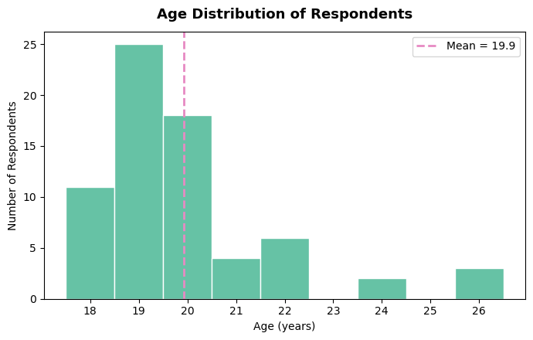
Figure 1: Age distribution of respondents (mean = 19.9 years)
Interpretation: The respondents are young: ages range from 18 to 26 with a mean of 19.9 years and a median of 19. Age 19 is the most common (25 students, 36.2%), and 54 of 69 respondents (78.3%) are between 18 and 20 years old. A few older respondents (24 and 26 years) are probably postgraduate or graduate students. The sample therefore mainly represents first- to third-year undergraduates.

6.1.2 Gender of respondents
Table 5: Gender distribution
Gender | No. of Respondents | Percentage
Male | 46 | 66.7%
Female | 22 | 31.9%
Other | 1 | 1.4%
Total | 69 | 100.0%

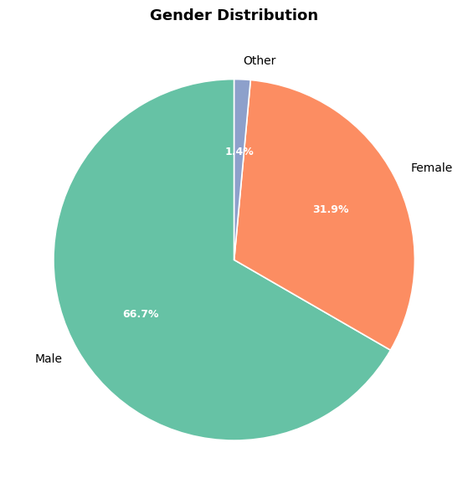
Figure 2: Gender distribution of respondents
Interpretation: Two-thirds of the respondents are male (66.7%), while 31.9% are female and one respondent (1.4%) chose “Other”. The male-heavy split reflects the class composition of the computing-oriented courses that dominate the sample.

6.1.3 Year / course of study
Table 6: Respondents by year / course of study
Year / Course | No. of Respondents | Percentage
SY Data Science | 31 | 44.9%
SY Computer Science | 9 | 13.0%
TY Computer Science | 8 | 11.6%
TY Data Science | 3 | 4.3%
Other classes / courses (18 different entries, 1 respondent each) | 18 | 26.1%
Total | 69 | 100.0%

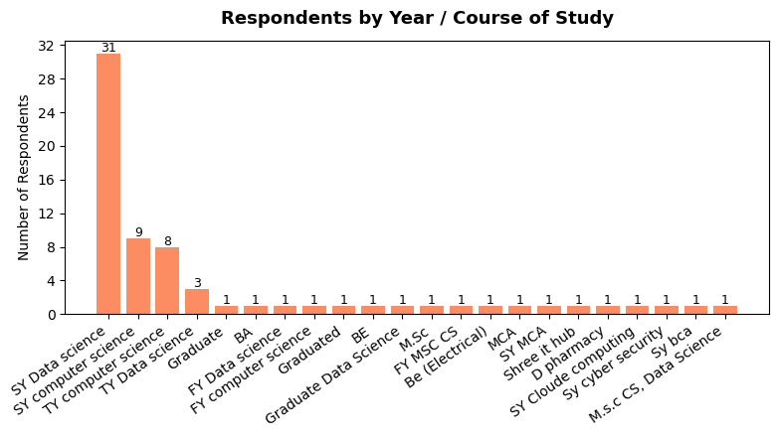
Figure 3: Respondents by year / course of study
Interpretation: SY Data Science students form the largest group (31 respondents, 44.9%), followed by SY Computer Science (9) and TY Computer Science (8). Together, SY/TY Data Science and Computer Science account for 51 of 69 respondents (73.9%). The remaining 18 respondents belong to a wide range of other classes such as FY, BA, BE, BCA, MCA, M.Sc. and D.Pharmacy. Results should therefore be read mainly as the views of computing students.

6.2 Digital Tool Usage Patterns

6.2.1 Use of digital learning tools
Table 7: Use of digital learning tools
Response | No. of Respondents | Percentage
Yes | 65 | 94.2%
No | 4 | 5.8%
Total | 69 | 100.0%

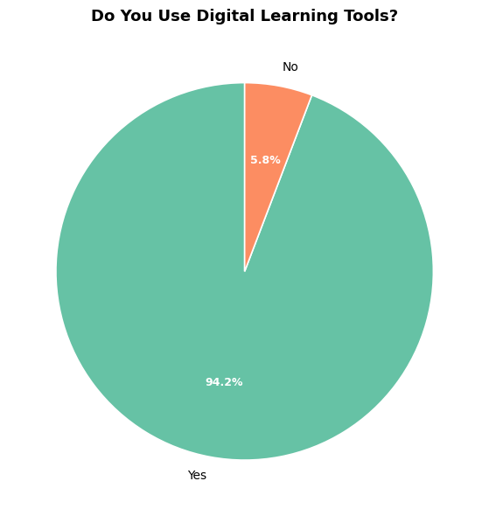
Figure 4: Do you use digital learning tools?
Interpretation: Digital learning tools are used almost universally: 65 of 69 respondents (94.2%) use them for their studies and only 4 (5.8%) do not.

6.2.2 Frequency of use
Table 8: Frequency of digital learning tool usage
Frequency | No. of Respondents | Percentage
Daily | 41 | 59.4%
4–6 days a week | 14 | 20.3%
2–3 days a week | 8 | 11.6%
Once a week | 5 | 7.2%
Rarely | 1 | 1.4%
Total | 69 | 100.0%

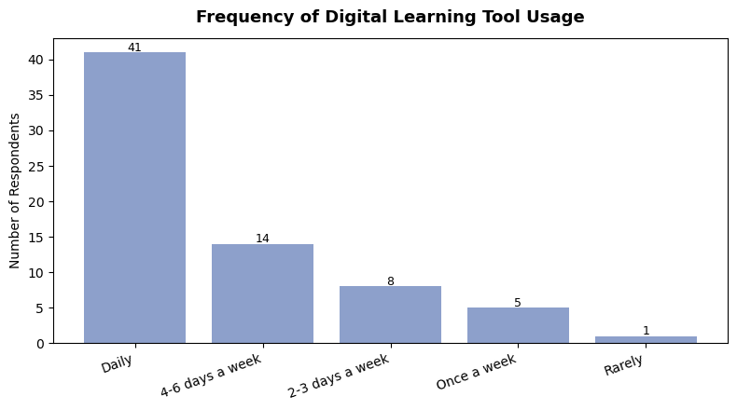
Figure 5: Frequency of digital learning tool usage
Interpretation: Usage is habitual: 41 students (59.4%) use digital tools every day and another 14 (20.3%) use them four to six days a week. Together, 55 respondents (79.7%) use them daily or almost daily. Only one student uses them rarely.

6.2.3 Time spent per day
Table 9: Time spent on digital learning tools per day
Time spent | No. of Respondents | Percentage
Less than 30 minutes | 11 | 15.9%
30 minutes – 1 hour | 21 | 30.4%
1 – 2 hours | 22 | 31.9%
2 – 3 hours | 3 | 4.3%
More than 3 hours | 12 | 17.4%
Total | 69 | 100.0%

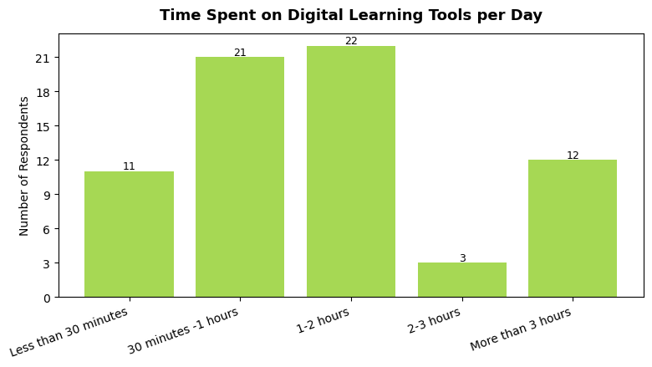
Figure 6: Time spent on digital learning tools per day
Interpretation: Most students spend a moderate amount of time on these tools: 43 respondents (62.3%) use them for 30 minutes to 2 hours a day. A sizeable group of 12 students (17.4%) spends more than 3 hours daily, which may indicate heavy dependence or long study and coding sessions. Only 3 students fall in the 2–3 hour band.

6.3 Tool Preference Analysis

6.3.1 Tools used
Table 10: Digital learning tools used (multiple response)
Tool | No. of Respondents | % of Respondents (n = 69)
ChatGPT / AI tools | 47 | 68.1%
YouTube | 47 | 68.1%
Google Classroom | 27 | 39.1%
Cloude (as entered in the form) | 18 | 26.1%
Education apps | 16 | 23.2%
Google Meet | 16 | 23.2%
Zoom | 13 | 18.8%
Duolingo | 10 | 14.5%
Coursera | 8 | 11.6%
Udemy (others) | 1 | 1.4%

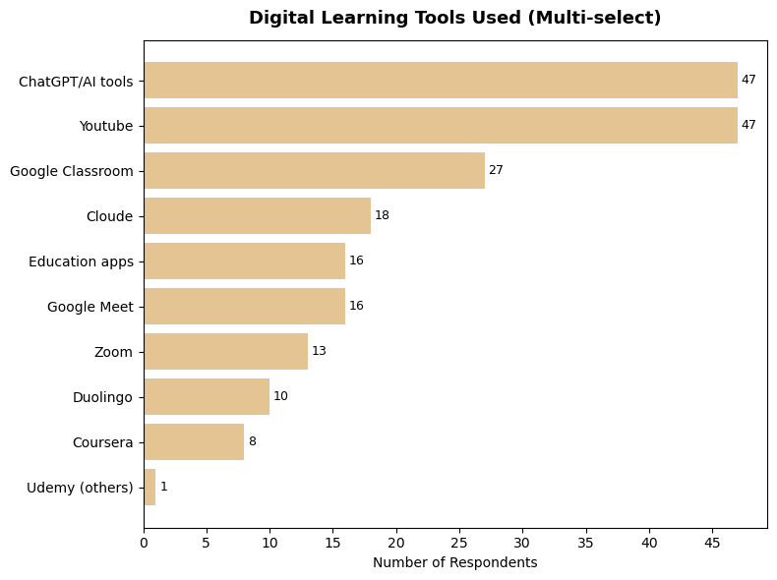
Figure 7: Digital learning tools used (multi-select)
Interpretation: ChatGPT / AI tools and YouTube share the first position, each used by 47 respondents (68.1%). Google Classroom (27, 39.1%) is the most used institutional platform, followed by cloud-based tools (18), educational apps and Google Meet (16 each), Zoom (13), Duolingo (10) and Coursera (8). AI tools and free video content clearly dominate over formal online-course platforms.

6.3.2 Tools considered most useful
Table 11: Tools considered most useful (multiple response)
Tool | No. of Respondents | % of Respondents (n = 69)
ChatGPT | 55 | 79.7%
Gemini | 17 | 24.6%
Cloude (as entered in the form) | 15 | 21.7%
Perfectly (as entered in the form) | 5 | 7.2%
Perplexity (others) | 1 | 1.4%

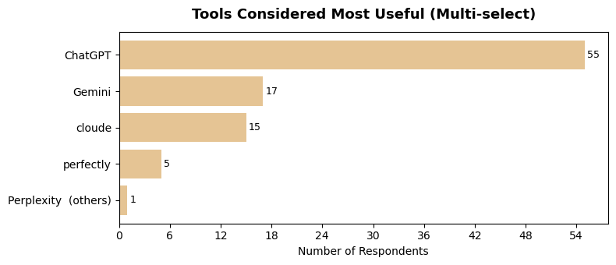
Figure 8: Tools considered most useful (multi-select)
Interpretation: ChatGPT is the clear favourite: 55 respondents (79.7%) rate it as most useful, well ahead of Gemini (17, 24.6%) and Cloude (15, 21.7%). Students also try more than one AI assistant, as the counts add up to more than 69.
Note: entries such as “Cloude” and “Perfectly” are shown exactly as typed by respondents; they most likely refer to the AI assistants Claude and Perplexity.

6.4 Perceived Usefulness, Benefits and Advantages

6.4.1 Perceived helpfulness
Table 12: Perceived helpfulness of digital learning tools
Rating | No. of Respondents | Percentage
Slightly helpful | 9 | 13.0%
Moderately helpful | 11 | 15.9%
Very helpful | 38 | 55.1%
Extremely helpful | 11 | 15.9%
Total | 69 | 100.0%

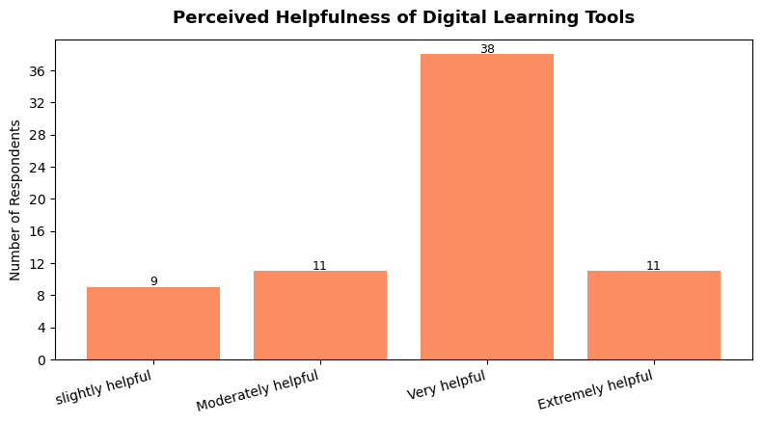
Figure 9: Perceived helpfulness of digital learning tools
Interpretation: More than half of the students (38, 55.1%) find digital tools “very helpful” and 11 (15.9%) find them “extremely helpful”, so 49 respondents (71.0%) give a strongly positive rating. No respondent rated the tools as not helpful at all.

6.4.2 Main benefits reported
Table 13: Main benefits of digital learning tools (multiple response)
Benefit | No. of Respondents | % of Respondents (n = 69)
All of the benefits | 22 | 31.9%
Better understanding of difficult topics | 21 | 30.4%
Quick access to information | 7 | 10.1%
Helps in assignments / projects | 7 | 10.1%
Saves time | 4 | 5.8%
Improves technical / learning skills | 4 | 5.8%
Important for exam preparation | 3 | 4.3%
Provides additional study material | 1 | 1.4%

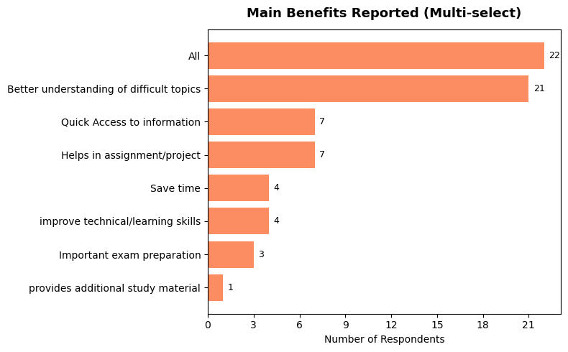
Figure 10: Main benefits reported (multi-select)
Interpretation: The largest group (22 students, 31.9%) selected every benefit, while 21 students (30.4%) specifically named better understanding of difficult topics. Quick access to information and help with assignments and projects follow with 7 responses each. Students therefore value the tools most for understanding and convenience, and less for exam preparation.

6.4.3 Biggest single advantage
Table 14: Biggest advantage of digital learning tools
Advantage | No. of Respondents | Percentage
All of the above | 23 | 33.3%
Easy and quick access to information | 18 | 26.1%
Saves time | 13 | 18.8%
Easy explanation of difficult concepts | 9 | 13.0%
Flexibility to study anytime and anywhere | 5 | 7.2%
Easy revision through recorded lectures | 1 | 1.4%
Total | 69 | 100.0%

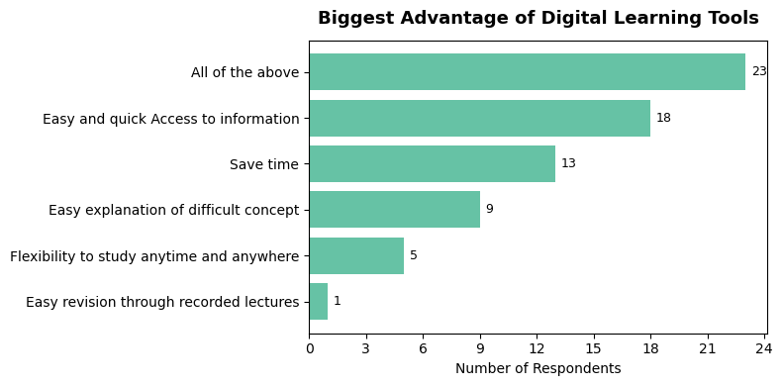
Figure 11: Biggest advantage of digital learning tools
Interpretation: “All of the above” leads (23, 33.3%), followed by easy and quick access to information (18, 26.1%) and time saving (13, 18.8%). Speed and convenience are therefore the advantages students notice first, followed by simple explanation of difficult concepts (9).

6.5 Trust, Overall Experience, Device and Access

6.5.1 Perceived accuracy and reliability
Table 15: Perceived accuracy and reliability of digital tools
Rating | No. of Respondents | Percentage
Very inaccurate | 2 | 2.9%
Moderately inaccurate | 3 | 4.3%
Neutral / moderately accurate | 13 | 18.8%
Accurate | 22 | 31.9%
Highly accurate | 29 | 42.0%
Total | 69 | 100.0%

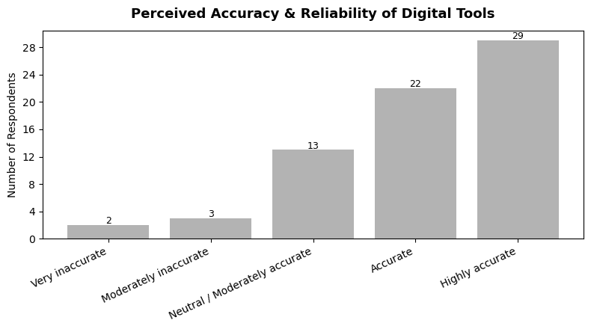
Figure 12: Perceived accuracy and reliability of digital tools
Interpretation: Trust in the tools is high: 29 respondents (42.0%) consider them highly accurate and 22 (31.9%) accurate, i.e. 51 of 69 (73.9%). Thirteen students (18.8%) are neutral and only 5 (7.2%) consider the tools inaccurate, which shows that a small but real group doubts the reliability of the information.

6.5.2 Overall experience
Table 16: Overall experience with digital learning tools
Rating | No. of Respondents | Percentage
Very poor | 4 | 5.8%
Poor | 2 | 2.9%
Average | 6 | 8.7%
Good | 24 | 34.8%
Excellent | 33 | 47.8%
Total | 69 | 100.0%

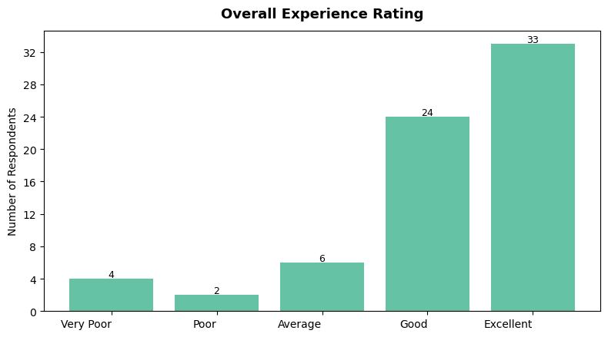
Figure 13: Overall experience rating
Interpretation: Satisfaction is high: 33 students (47.8%) rate their overall experience as excellent and 24 (34.8%) as good, so 57 respondents (82.6%) are satisfied. Only 6 students (8.7%) report a poor or very poor experience.

6.5.3 Primary device
Table 17: Primary device used for digital learning
Device | No. of Respondents | Percentage
Smartphone | 37 | 53.6%
Laptop | 27 | 39.1%
Tablet | 3 | 4.3%
Desktop | 2 | 2.9%
Total | 69 | 100.0%

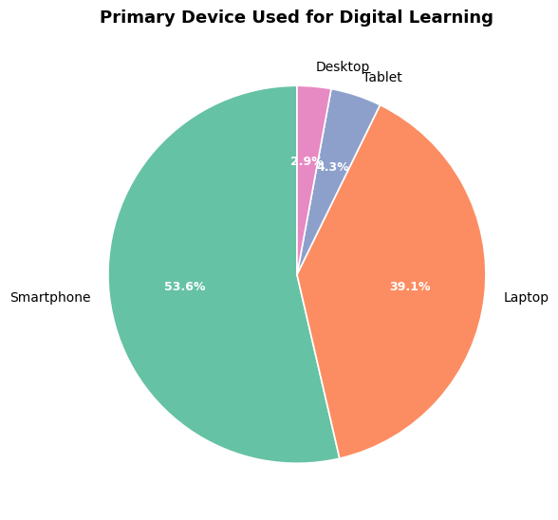
Figure 14: Primary device used for digital learning
Interpretation: The smartphone is the main learning device (37 students, 53.6%), followed by the laptop (27, 39.1%). Tablets (4.3%) and desktops (2.9%) are rarely used. Digital learning content and tools should therefore be mobile-friendly.

6.5.4 Primary location of access
Table 18: Primary location of access
Location | No. of Respondents | Percentage
Home | 38 | 55.1%
College | 23 | 33.3%
Hostel | 4 | 5.8%
Library | 4 | 5.8%
Total | 69 | 100.0%

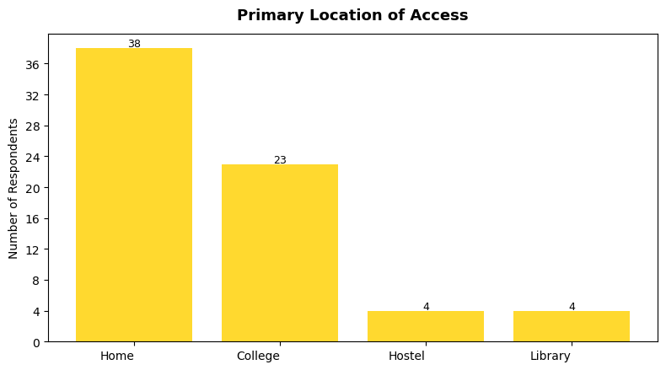
Figure 15: Primary location of access
Interpretation: Home is where most students use digital tools (38, 55.1%), followed by the college (23, 33.3%). Hostel and library account for 4 respondents each (5.8%). Since a third of students rely on college access, campus internet quality matters.

6.6 Challenges, Cost Perception and AI Usage

6.6.1 Problems faced
Table 19: Problems faced while using digital learning tools
Problem | No. of Respondents | Percentage
Paid / limited features | 41 | 59.4%
Internet connectivity issues | 17 | 24.6%
Incorrect or misleading information | 6 | 8.7%
Privacy concerns | 5 | 7.2%
Total | 69 | 100.0%

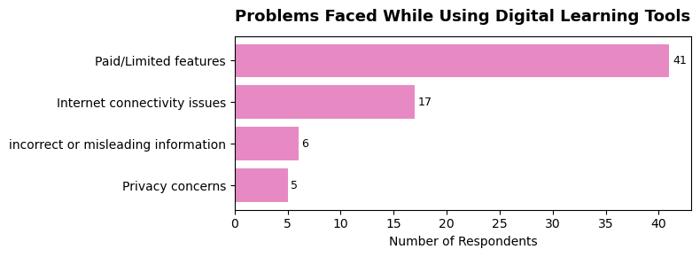
Figure 16: Problems faced while using digital learning tools
Interpretation: Paid or limited features are by far the biggest complaint (41 students, 59.4%), followed by internet connectivity problems (17, 24.6%). Incorrect or misleading information (6) and privacy concerns (5) are mentioned by fewer students. Cost and access, rather than tool quality, are the main barriers.

6.6.2 Cost of digital versus offline learning
Table 20: Perceived cost of digital learning compared with offline learning
Opinion | No. of Respondents | Percentage
Much more expensive | 18 | 26.1%
Slightly more expensive | 18 | 26.1%
Almost the same | 15 | 21.7%
Slightly cheaper | 10 | 14.5%
Much cheaper | 8 | 11.6%
Total | 69 | 100.0%

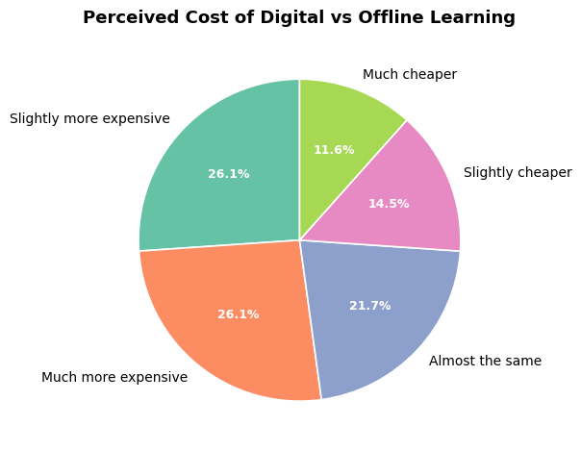
Figure 17: Perceived cost of digital vs. offline learning
Interpretation: Opinion is divided. A small majority (36 students, 52.2%) feel digital learning is more expensive than offline learning, 15 (21.7%) see no difference and 18 (26.1%) consider it cheaper.

6.6.3 Which type of learning is costlier
Table 21: Which type of learning is seen as more costly
Opinion | No. of Respondents | Percentage
Digital learning tools | 24 | 34.8%
Offline learning | 23 | 33.3%
Depends on the course / institute | 20 | 29.0%
Both cost almost the same | 2 | 2.9%
Total | 69 | 100.0%

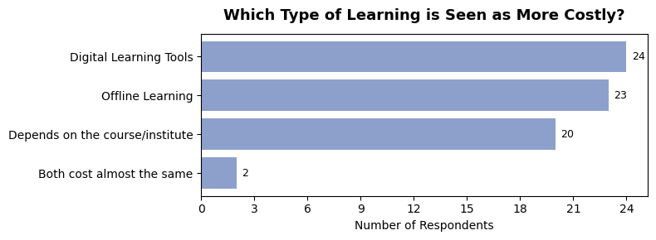
Figure 18: Which type of learning is seen as more costly?
Interpretation: Views are almost evenly split between digital tools (24, 34.8%), offline learning (23, 33.3%) and “it depends on the course or institute” (20, 29.0%). There is no clear consensus, which suggests that cost perception depends on the tools and courses a student uses.

6.6.4 Primary purpose of using AI tools
Table 22: Primary purpose of using AI tools
Purpose | No. of Respondents | Percentage
Clearing doubts and complex concepts | 28 | 40.6%
Coding / programming, debugging and help | 26 | 37.7%
Preparing assignments and project reports | 8 | 11.6%
Translation and grammar correction | 5 | 7.2%
Understanding maths and statistics step by step | 2 | 2.9%
Total | 69 | 100.0%

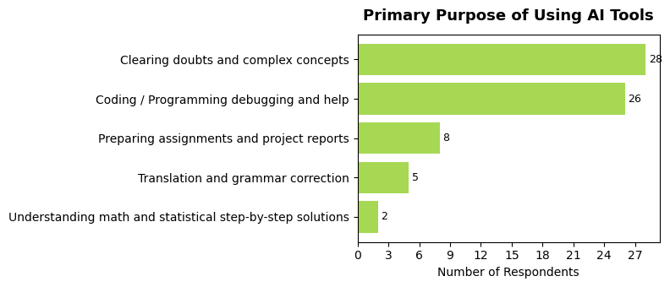
Figure 19: Primary purpose of using AI tools
Interpretation: AI tools are used mainly as a learning aid rather than only for assignments. Clearing doubts and complex concepts (28, 40.6%) and coding help (26, 37.7%) together account for 78.3% of responses, while preparing assignments and reports comes third (8, 11.6%). The high share of coding help matches the computing background of the sample.

6.7 Cross-Tabulation and Correlation Analysis

6.7.1 Usage frequency versus perceived helpfulness
Table 23: Usage frequency vs. perceived helpfulness (no. of respondents)
Frequency | Slightly | Moderately | Very | Extremely | Total
Daily | 6 | 4 | 22 | 9 | 41
4–6 days a week | 2 | 3 | 8 | 1 | 14
2–3 days a week | 1 | 2 | 5 | 0 | 8
Once a week | 0 | 2 | 3 | 0 | 5
Rarely | 0 | 0 | 0 | 1 | 1
Total | 9 | 11 | 38 | 11 | 69

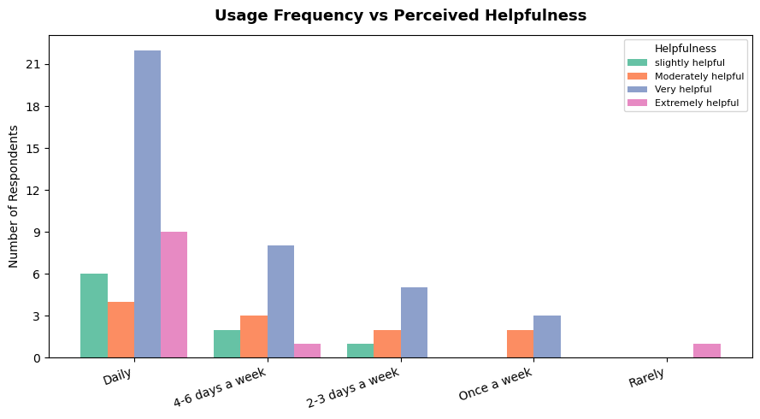
Figure 20: Usage frequency vs. perceived helpfulness
Interpretation: Students who use digital tools daily contribute the highest counts of “very helpful” (22) and “extremely helpful” (9) ratings, i.e. 31 of 41 daily users (75.6%) give one of the two top ratings. Among students using the tools 4–6 days a week the figure is 9 of 14 (64.3%), and among those using them 2–3 days a week it is 5 of 8 (62.5%). Frequent users therefore tend to perceive more benefit, although the small numbers in the less frequent groups call for caution.

6.7.2 Correlation matrix
Ordinal responses were converted into numerical scores (Frequency: Rarely = 1 … Daily = 5; Helpfulness: Slightly = 1 … Extremely = 4; Accuracy: Very inaccurate = 1 … Highly accurate = 5; Experience: Very poor = 1 … Excellent = 5) and Pearson correlation coefficients (r) were calculated.
Table 24: Pearson correlation matrix
 | Age | Usage Freq. | Helpfulness | Trust (Accuracy) | Overall Exp.
Age | 1.00 | 0.23 | 0.02 | 0.16 | 0.19
Usage Freq. | 0.23 | 1.00 | 0.05 | 0.33 | 0.53
Helpfulness | 0.02 | 0.05 | 1.00 | -0.06 | -0.02
Trust (Accuracy) | 0.16 | 0.33 | -0.06 | 1.00 | 0.69
Overall Exp. | 0.19 | 0.53 | -0.02 | 0.69 | 1.00

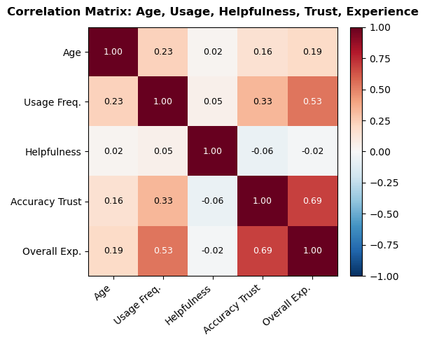
Figure 21: Correlation heatmap: age, usage frequency, helpfulness, accuracy / trust and overall experience
Interpretation: The strongest relationship in the data is between trust in accuracy and overall experience (r ≈ 0.69): students who trust the information from digital tools rate their overall experience much higher. Usage frequency and overall experience (r ≈ 0.53) show a moderate positive relationship, so students who use the tools more often also report a better experience. Usage frequency and trust are weakly related (r ≈ 0.33). Age and the helpfulness rating show almost no correlation with the other variables; the helpfulness rating has little variation because most students chose “very helpful”. These are correlations from a small sample and do not prove cause and effect.

6.8 Summary of Analysis
Table 25: Summary of key results
Metric | Result
Total respondents | 69
Average age | 19.9 years (range 18–26)
Gender | Male 66.7%, Female 31.9%, Other 1.4%
Use digital learning tools | 94.2%
Use tools daily / 4–6 days a week | 79.7%
Most used tools | YouTube and ChatGPT / AI tools (47 each)
Tool rated most useful | ChatGPT (55 respondents)
Find tools very / extremely helpful | 71.0%
Top reported benefits | All-round benefit; better understanding of difficult topics
Rate accuracy as accurate / highly accurate | 73.9%
Rate overall experience good / excellent | 82.6%
Most used device | Smartphone (53.6%)
Top problem faced | Paid / limited features (59.4%)
Top purposes of AI tools | Clearing doubts (28); coding help (26)
Correlation: usage frequency – experience | r ≈ 0.53
Correlation: trust in accuracy – experience | r ≈ 0.69

7. Findings, Conclusions and Recommendations

7.1 Findings of the Study
The main findings, arranged according to the objectives of the study, are given in Table 26.
Table 26: Objective-wise findings
Objective | Key finding
1. Tools commonly used | ChatGPT / AI tools and YouTube are the most used (47 each), followed by Google Classroom (27). ChatGPT is rated most useful by 55 respondents.
2. Frequency of use | 94.2% use digital learning tools; 79.7% use them daily or 4–6 days a week; 62.3% spend 30 minutes to 2 hours per day.
3. Purposes of use | AI tools are mainly used for clearing doubts (28) and coding help (26); assignments and reports come next (8). Students mainly benefit from better understanding of difficult topics and quick access to information.
4. Perceived usefulness | 71.0% find the tools very or extremely helpful and 73.9% consider them accurate or highly accurate.
5. Academic performance | Students perceive the tools as supporting their studies through better understanding, help with assignments and exam preparation. Actual marks were not measured, so this is a perception only.
6. Productivity and understanding | Saving time (13 as biggest advantage), easy and quick access (18) and easy explanation of difficult concepts (9) show a positive effect on productivity and understanding.
7. Challenges | Paid / limited features (59.4%) and internet connectivity issues (24.6%) are the main problems; incorrect information (6) and privacy concerns (5) are less frequent.
8. Overall satisfaction | 82.6% rate their experience as good or excellent; 8.7% report a poor or very poor experience.
9. Insights for improvement | Trust in accuracy (r ≈ 0.69) and frequency of use (r ≈ 0.53) are linked to a better experience; access and affordability are the main barriers.

Other findings
- The smartphone is the primary device (53.6%) and home is the primary place of access (55.1%).
- Cost perception is divided: 52.2% feel digital learning is more expensive than offline learning, 21.7% feel it is almost the same and 26.1% feel it is cheaper.
- Age makes almost no difference to how helpful students find the tools (r ≈ 0.02).

7.2 Conclusions
The study “Survey on Digital Learning Tools Usage Among College Students” set out to understand the role of digital technology in students’ academic lives. The analysis of 69 responses shows that digital learning tools have near-universal adoption (94.2%) among the surveyed students, with the majority using them daily or almost daily and spending 30 minutes to 2 hours a day on them.
YouTube and ChatGPT / AI tools dominate the tool landscape, and AI tools are used mainly to clear doubts on complex concepts and for coding and assignment help. Perceived helpfulness and overall experience are strongly positive: 71% find the tools very or extremely helpful and 82.6% rate their overall experience as good or excellent. Overall experience correlates most closely with trust in the accuracy of information (r ≈ 0.69) and with usage frequency (r ≈ 0.53), which indicates that students who use these tools more, and trust them more, rate their experience higher.
The main friction points are paid or limited features and internet connectivity issues, suggesting that affordability and access, not tool quality, remain the biggest barriers to digital learning. Cost perception is split roughly evenly between digital tools being seen as more expensive, cheaper or about the same as offline learning.
These findings help educators and institutions understand how students actually use digital technology in their studies. They highlight two priorities: (a) improving access to free or affordable tiers of key tools, and (b) improving and communicating the accuracy and reliability of AI-based learning tools, since trust is the single strongest driver of a positive learning experience.

7.3 Recommendations
- Institutions could negotiate discounted or campus-wide licences for the most used paid tools to address the “paid / limited features” barrier reported by 41 of 69 students.
- Improving campus Wi-Fi and internet access would directly address the second most common problem (connectivity issues, 17 respondents).
- Given the strong link between trust and experience (r ≈ 0.69), students would benefit from guidance on verifying AI-generated answers, and instructors could recommend vetted AI and education tools.
- Since ChatGPT / AI tools are used heavily for coding help and clearing doubts, structured AI-literacy sessions could help students use these tools more effectively and critically.
- As most students learn on smartphones, study material and college platforms should be mobile-friendly and light on data.
- The college can share simple guidelines on privacy and responsible use of AI tools, to address the concerns about misleading information and privacy raised by some respondents.

7.4 Limitations of the Study
- The study is limited to students who responded to the online survey.
- The accuracy of the results depends on the honesty of respondents.
- The sample size (69) may not represent all college students.
- Students from different colleges and backgrounds may have different digital learning experiences; about three-fourths of the sample (73.9%) is concentrated in SY/TY Data Science and Computer Science courses.
- The study focuses mainly on students’ self-reported perceptions and usage patterns rather than objective or measured academic performance.

7.5 Scope for Further Study
The study can be extended by surveying a larger and more varied sample from several colleges and streams, by comparing usage across classes and courses, by including measured academic results, and by repeating the survey after some time to see how AI-tool usage changes.

8. Learning Outcomes and Personal Experience

8.1 Learning Outcomes
Through this field project I achieved the following learning outcomes:
- Research skills: I learned how to select a topic, frame a problem statement, set objectives and design a descriptive survey.
- Questionnaire design: I learned to prepare a Google Form with clear, closed-ended questions that can be analyzed easily.
- Data handling: I learned to clean real-world data: renaming columns, removing personal information, handling text inconsistencies, checking for missing values and duplicates, and splitting multi-select answers.
- Python for data analysis: I gained practical experience with Pandas, NumPy, Matplotlib and Seaborn in a Jupyter notebook, including frequency tables, cross-tabulation, correlation analysis and charts.
- Interpretation: I learned to move from numbers and charts to meaningful statements, and to be careful about the difference between correlation and cause.
- Report writing: I learned to organize findings into a structured report with tables, figures, conclusions and recommendations.

8.2 Personal Experience
Working on this project was a valuable experience because I could apply what I learned in the Data Science classroom to a real problem that concerns students like me. Collecting responses from fellow students showed me how important it is to make a questionnaire short and clear, and how the quality of the analysis depends on the quality of the data.
Cleaning the raw data taught me that real data is never perfect. Free-text entries had spelling variations, multi-select answers had to be split before counting, and one duplicate row had to be examined. Handling these details patiently was as important as drawing the charts.
The most interesting result for me was that trust in the accuracy of digital tools is more strongly linked to a good learning experience than how helpful students rate the tools. It made me realize that students must learn to verify AI-generated information and not accept it blindly. I also found that paid features and internet problems, not the tools themselves, trouble students most.

8.3 Difficulties Faced
- Getting enough responses within the limited time of the survey.
- Cleaning inconsistent text entries and multi-select answers.
- Deciding how to convert ordinal answers into numerical scores for correlation analysis.
- Presenting the results with a small, convenience-based sample without over-generalizing.

8.4 Skills Developed
Apart from technical skills, this project improved my communication with respondents, time management, attention to detail, and my ability to explain data in simple language. It has also increased my confidence to carry out larger data-analysis projects in the future.

9. References

Books and Journals
- Kothari, C. R. (2004). Research Methodology: Methods and Techniques (2nd revised ed.). New Age International Publishers, New Delhi.
- McKinney, W. (2022). Python for Data Analysis (3rd ed.). O’Reilly Media.
- Harris, C. R., et al. (2020). Array programming with NumPy. Nature, 585, 357–362.
- Hunter, J. D. (2007). Matplotlib: A 2D graphics environment. Computing in Science & Engineering, 9(3), 90–95.
- Waskom, M. L. (2021). seaborn: statistical data visualization. Journal of Open Source Software, 6(60), 3021.
- Ministry of Education, Government of India (2020). National Education Policy 2020.

Software Documentation and Websites
- pandas development team. pandas documentation. https://pandas.pydata.org/docs/
- Matplotlib development team. Matplotlib documentation. https://matplotlib.org/stable/
- Seaborn documentation. https://seaborn.pydata.org/
- Project Jupyter. Jupyter Notebook documentation. https://jupyter.org/
- Google Forms. https://forms.google.com

Data Sources
Primary data: online questionnaire (Google Form), 69 responses, collected 21 August – 7 September 2026. Analysis notebook: field_project.ipynb (Pandas, NumPy, Matplotlib, Seaborn). Exported dataset: ganesh.csv.

Annexure A: Survey Questionnaire
[Replace this page with the exact printout of your Google Form. The questions below are reconstructed from the survey data and may differ in wording.]
Survey on Digital Learning Tools Usage Among College Students
This survey is part of the field project of B.Sc. (Data Science). The information will be used only for academic purposes.

Section A: Personal Information
1. Name
☐ Short answer: ______________________
2. Age (in years)
☐ Short answer: ________
3. Gender
☐ Male
☐ Female
☐ Other
4. Year / Course of study
☐ Short answer: ______________________ (e.g. SY Data Science)

Section B: Use of Digital Learning Tools
5. Do you use digital learning tools for your studies?
☐ Yes
☐ No
6. Which digital learning tools do you use? (You may select more than one)
☐ Google Classroom
☐ YouTube
☐ Zoom
☐ Google Meet
☐ Coursera
☐ Duolingo
☐ Educational apps
☐ Cloud-based tools
☐ ChatGPT / AI tools
☐ Other: __________
7. How frequently do you use digital learning tools?
☐ Daily
☐ 4–6 days a week
☐ 2–3 days a week
☐ Once a week
☐ Rarely
8. How much time do you spend on digital learning tools per day?
☐ Less than 30 minutes
☐ 30 minutes – 1 hour
☐ 1 – 2 hours
☐ 2 – 3 hours
☐ More than 3 hours

Section C: Usefulness, Benefits and Trust
9. Which digital tool do you find most useful? (You may select more than one)
☐ ChatGPT
☐ Gemini
☐ Other: __________
10. How helpful are digital learning tools for your studies?
☐ Slightly helpful
☐ Moderately helpful
☐ Very helpful
☐ Extremely helpful
11. What are the main benefits of using digital learning tools? (You may select more than one)
☐ Quick access to information
☐ Better understanding of difficult topics
☐ Helps in assignments / projects
☐ Saves time
☐ Improves technical / learning skills
☐ Important for exam preparation
☐ Provides additional study material
☐ All of the above
12. What is the biggest advantage of digital learning tools?
☐ Easy and quick access to information
☐ Saves time
☐ Easy explanation of difficult concepts
☐ Flexibility to study anytime and anywhere
☐ Easy revision through recorded lectures
☐ All of the above
13. How accurate and reliable do you find the information from digital tools?
☐ Very inaccurate
☐ Moderately inaccurate
☐ Neutral / moderately accurate
☐ Accurate
☐ Highly accurate
14. How would you rate your overall experience with digital learning tools?
☐ Very poor
☐ Poor
☐ Average
☐ Good
☐ Excellent

Section D: Device, Access, Problems and Cost
15. Which device do you mainly use for digital learning?
☐ Smartphone
☐ Laptop
☐ Tablet
☐ Desktop
16. Where do you mainly access digital learning tools?
☐ Home
☐ College
☐ Hostel
☐ Library
17. What is the main problem you face while using digital learning tools?
☐ Paid / limited features
☐ Internet connectivity issues
☐ Incorrect or misleading information
☐ Privacy concerns
18. Compared with offline learning, how costly is digital learning?
☐ Much more expensive
☐ Slightly more expensive
☐ Almost the same
☐ Slightly cheaper
☐ Much cheaper
19. Which type of learning is more costly?
☐ Digital learning tools
☐ Offline learning
☐ Both cost almost the same
☐ Depends on the course / institute

Section E: AI Tools
20. What is your primary purpose of using AI tools?
☐ Clearing doubts and complex concepts
☐ Coding / programming, debugging and help
☐ Preparing assignments and project reports
☐ Translation and grammar correction
☐ Understanding maths and statistics step by step

Filled Questionnaires
[Attach printouts / screenshots of the filled Google Form responses (response sheet) here.]

Annexure B: Continuous Assessment Chart
Name of the Student: Waghmare Ganesh Jalindar | Class: SY B.Sc. Data Science | Roll No./PRN: 81
Name of the Mentor: Prof. Arjana Shaikh | Title of the Field Project: “Survey on Digital Learning Tools Usage Among College Students”

Week | No. of Hours | Work done by the Student | Guide Remark & Sign
1 |  | Read the handbook; selected the title; drafted objectives and synopsis; submitted synopsis to mentor
2 |  | Studied the topic and reviewed literature; finalized the problem statement, objectives and scope
3 |  | Designed the survey questionnaire and prepared the Google Form
4 |  | Circulated the questionnaire and collected responses from students
5 |  | Continued data collection; exported the responses as a CSV file
6 |  | Cleaned and prepared the data in Python (Pandas, NumPy)
7 |  | Analyzed the data and prepared charts, tables and interpretations
8 |  | Wrote the findings, conclusions and recommendations; completed and submitted the report
Total: 60 hours (Field work minimum 30 hours + table/report work)
Head of the Department: Sign & Seal

Annexure C: Letter of Authority and Field Photographs

C.1 Letter of Authority (copy)
[Paste a copy of the Letter of Authority here]

C.2 Field Photographs
Photographs of the field work (for example, sharing the survey with students and collecting responses) may be pasted below with a short caption.
[Paste field photograph 1 here]

[Paste field photograph 2 here]

